Takashi Sado, Nathan Williams and James Pierce   
BMCH 8410   
11/8/2017

# Hydraulic Damper for Hand Tremor - Parkinson’s Disease (PD)

## Drawings and Descriptions Technical Field

The primary function of this device is to lessen the severity and quality of life (QoL) impact of tremors of the hand, in particular for individuals with Parkinson’s Disease. The proposed apparatus will passively reduce the amplitude of resting and active tremor of the hand and wrist; in particular, pronation/supination and adduction/abduction tremors (typical of PD) will be the most reduced. The proposed device will be manufactured using additive manufacturing and will be minimally invasive, with no impact on overall range of motion (ROM).

The Mayo Clinic estimates that over 200,000 individuals are diagnosed with PD each year, making it one of the most common neuropathologies affecting movement in the elderly/aging population. Of its symptoms, tremor, bradykinesia (slowed movement), and communication (slurred speech and micrographia) are cited as most debilitating. The proposed apparatus seeks to alleviate many of these QoL issues, primarily through reducing tremor affecting upper-limb manipulation and writing.

### Drawings

The detailed description is described with reference to the accompanying figures. The use of the same reference numbers in different instances in the description and the figures may indicate similar or identical items.

**Fig. 1** is a concept drawing of a hand fitted with the proposed device.

**Fig. 2** shows spatial positioning considerations for passive impedance components of the apparatus.

**Fig. 3** depicts a scale drawing of the proposed device, with selected hydraulic dampers being superimposed for better visualization.

**Fig. 4** shows various views of a Computer-Aided Engineering (CAE) design of the device, with included hydraulic damper assemblies.

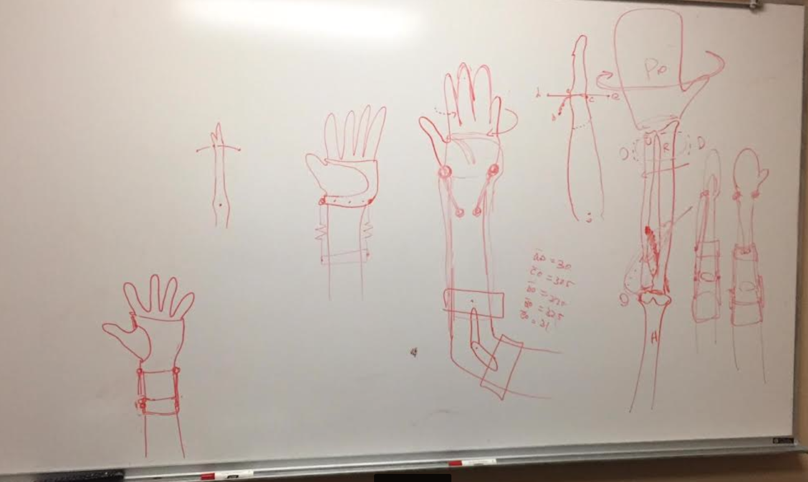

Figure 1



Figure 2

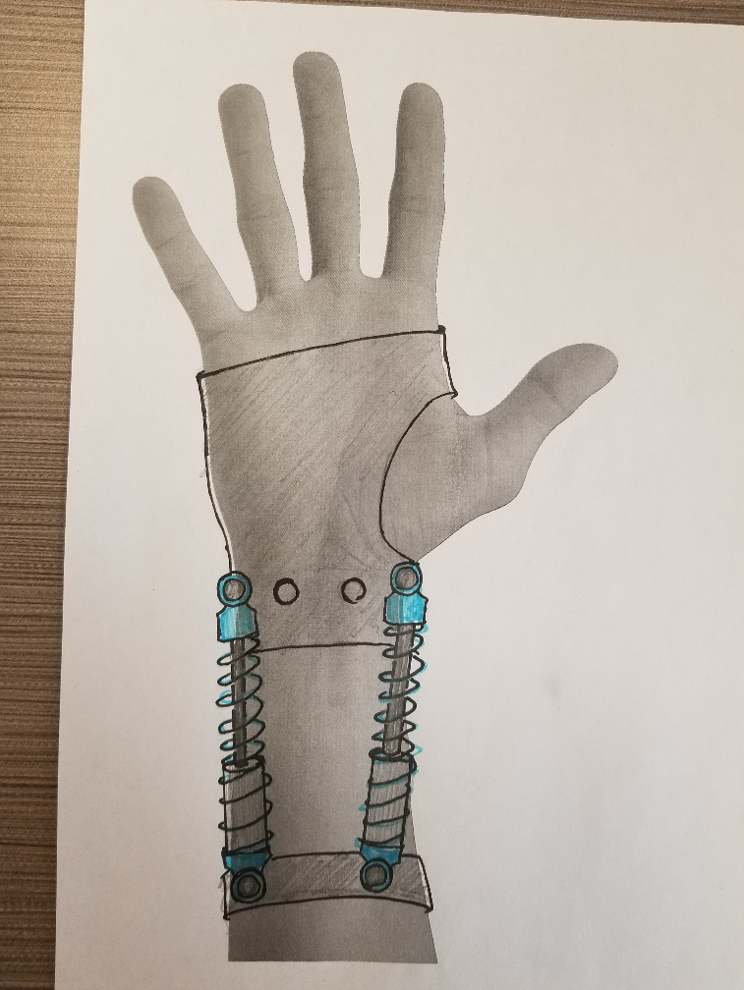

Figure 3

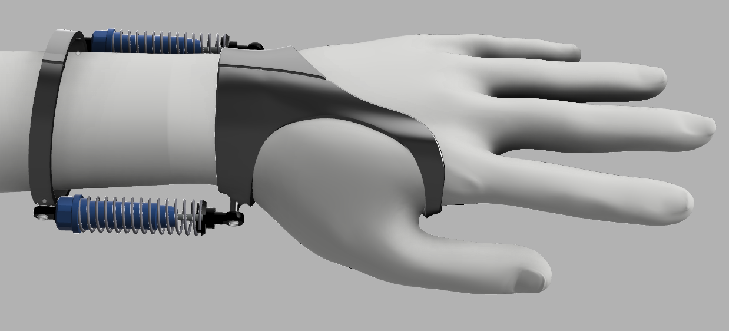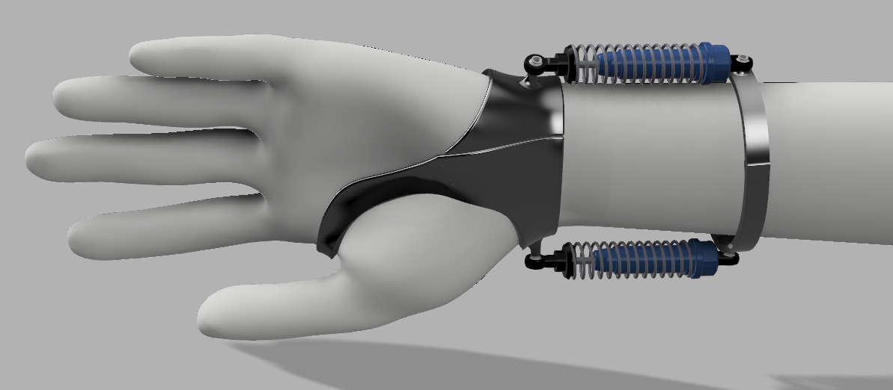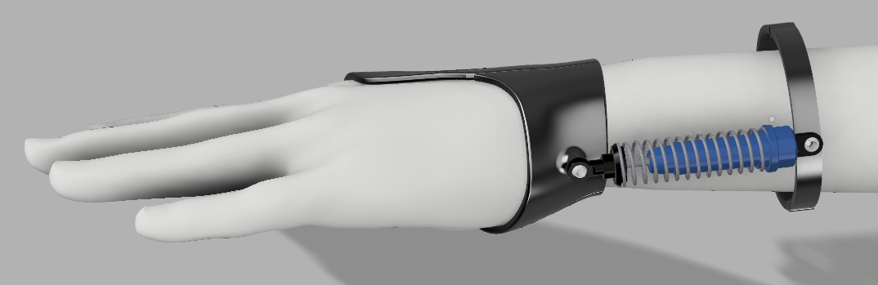

Figure 4

### Detailed Description

For the purposes of promoting and understanding of the principles of the invention, reference will be made to the embodiments illustrated in the drawings and specific language will be used to describe the same. It will nevertheless be understood that no limitation of the scope of the invention is hereby intended. Alterations and further modifications in the illustrated devices, and such further applications of the principles of the invention as illustrated herein are contemplated as would normally occur to one skilled in the art to which the invention relates.

The hydraulic damper system in the device comprises of two or more sets of hydraulic dampers, with a hydraulic ram with or without spring for added resistance to motion. The viscosity of the hydraulic fluid in the incorporated dampers may also be customized to allow for optimal movement capability and tremor reduction.

A rotationally isolated mounting ring is employed midway along the user’s forearm, and is attached indirectly to the elbow to isolate itself from pronation/supination motion throughout the forearm. Each hydraulic damper is then attached to this ring to provide impedance during wrist motion (especially pronation/supination and adduction/abduction).

### Description of Drawings

Figure 1.

1. Concept Sketch of Apparatus with Damper System
   1. The hydraulic dampers will be located in such a way that they impede rapid, high amplitude movements of the wrist that are caused by tremor.
   2. These hydraulic dampers physically correct unintentional movements (≤ 5Hz) introduced by dopamine deficiency from substantia nigra degradation.
2. Schematic Diagram of a Hydraulic Damper/Dashpot
   1. Hydraulic dampers/dashpots serve to impede motion through viscous friction of the hydraulic fluid through orifices of a precisely-controlled diameter in the ram’s piston.
      1. Viscous resistance provided by the dashpots is directly proportional to the impulse of the applied force, which serves to resist fast and high amplitude motion more than slow and controlled motion.
      2. Resistance to fast and large movements will impede tremor while allowing slower and more controlled movements from the user, essentially acting as a physical low pass filter.

Figure 2.

1. Schematic Figure of Hydraulic Ram Travel
   1. Line segments/arcs marked on each of the sketches show approximated dashpot end-point travel for various motions of the hand.
      1. Dashpot actuation will be greatest for pronation/supination motions due to rotational aspects of the motion.
      2. Actuation will be negligible for flexion/extension movements, allowing for unaffected ROM.
2. Anatomical rotation of the forearm
   * 1. Because rotation happens for the ulna/radius along the entire length of the forearm, the proximal attachments for dashpots must be isolated from that rotation; in particular, through fixation to more proximal arm structures (i.e. humerus).

Figure 3.

1. Scale Concept Drawings of the Proposed Apparatus
   1. This figure depicts anatomically-accurate and to-scale layout of components for the proposed apparatus.
   2. Dashpot placement has been optimized in this sketch, and appropriately sized impedance components have been drawn/sourced.
      1. Additional possible attachment points have been added for improved customizability.

Figure 4.

1. Various Views of a CAE Design of the Device with Included Hydraulic Damper Assemblies
   1. Isolated rotation ring and hand attachments for the proposed device have been modeled for easy fitting and use
      1. Both components are split for easy fitting over each half of the hand/forearm and fastening along the midline
   2. Hydraulic dampers have been located longitudinally along the axes of the ulna and radius
      1. This maximizes hydraulic impedance for pronation/supination, which are prominent aspects of PD tremor
      2. This minimizes the impact on ROM for flexion/extension, pronation/supination and adduction/abduction of the wrist
      3. Impedance for flexion/extension will be negligible
      4. Impedance for adduction/abduction will be small

## Motor Control Justification

**How does tremor occur?**

* The core pathological process in Parkinson’s disease involves dopaminergic cell loss in the substantia nigra pars compacta, particularly the lateral ventral tier.
  + This causes the depletion of the dopamine level in the striatum, specifically in the dorsolateral putamen.
  + Although there are many hypotheses of how tremor is caused, depletion of the dopamine in the region of the substantia nigra compacta and thalamus, which closely work with the basal ganglia, causes the disruption in sensory feedbacks.
  + Due to the poor sensory feedback, some of the automatic movements, such as postural control and limb coordination are disturbed. Thus, tremor can be induced.

**Relevant Aspects of PD Tremor**

* Tremor is typically postural dependent. At rest, the frequency of tremor can range from 4 to 5 Hz or 8 to 10 Hz, but depending on the situation of patients’ posture, amplitude and frequency of the tremor can increase up to approximately 18 Hz.

**Importance of Tremor Reduction**

* Tremor is independent from other Parkinsonian symptoms. Tremor severity does not correlate to the other symptoms’ severity, and tremor can occur on the contralateral body side.
* Tremor responds less to medications and treatments to increase dopamine secretion compared to bradykinesia and rigidity.
* Parkinsonian tremor results from altered responses in both basal ganglia and the cerebello-thalamo-cortical circuit. This indicates that voluntary movements may interact with resting tremor in either or both of these circuits.
* Based on these ideas, our specific design will not restrict patients’ movement as they engage in voluntary movements, yet depending on the frequency of each patients, we can change the resistive force that is applied from the hydraulic damper by changing the viscosity in the device.

## Conclusion

Although the subject matter has been described in language specific to structural features and/or process operations, it is to be understood that the subject matter defined in the appended claims is not necessarily limited to the specific features or acts described above. Rather, the specific features and acts described above are disclosed as example forms of implementing the claims.

## References

1. Parkinson's disease. (2015, July 07). Retrieved November 08, 2017, from <https://www.mayoclinic.org/diseases-conditions/parkinsons-disease/basics/definition/con-20028488>
2. Mark H. Holmes (2009). Introduction to the Foundations of Applied Mathematics. Springer. p. 329. “the resistance force is proportional to the velocity”
3. Budynas, R. G. and Nisbett, J. K.: Shigleys mechanical engineering design, McGraw-Hill Education, New York, NY., 2015.
4. Helmich, R. C., Hallett, M., Deuschl, G., Toni, I., & Bloem, B. R. (2012). Cerebral causes and consequences of parkinsonian resting tremor: a tale of two circuits? Brain, 135(11), 3206–3226. http://doi.org/10.1093/brain/aws023